State Diagrams

Black Roses

sean khanna

Level 5

Contents

Player 2

Enemy 2

# Player

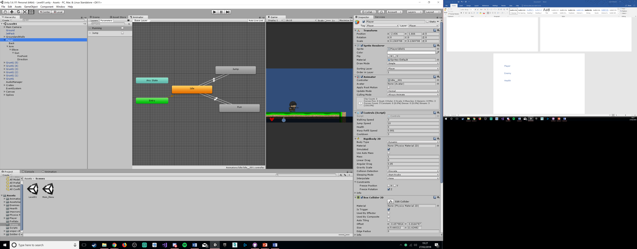

# Enemy

